**LED:**

**Introduction:**

A light-emitting diode (LED) is a semiconductor light source. LEDs are used as indicator lamps in many devices, and are increasingly used for lighting. Introduced as a practical electronic component in 1962, early LEDs emitted low-intensity red light, but modern versions are available across the visible, ultraviolet and infrared wavelengths, with very high brightness.

The LED is based on the semiconductor diode. When a diode is forward biased, electrons are able to recombine with holes within the device, releasing energy in the form of photons. This effect is called electroluminescence and the color of the light (corresponding to the energy of the photon) is determined by the energy gap of the semiconductor. An LED is usually small in area (less than 1 mm2), and integrated optical components are used to shape its radiation pattern and assist in reflection. LEDs present many advantages over incandescent light sources including lower energy consumption, longer lifetime, improved robustness, smaller size, faster switching, and greater durability and reliability. However, they are relatively expensive and require more precise current and heat management than traditional light sources. Current LED products for general lighting are more expensive to buy than fluorescent lamp sources of comparable output.

**Working:** Charge-carriers—electrons and holes—flow into the junction from electrodes with different voltages. When an electron meets a hole, it falls into a lower energy level, and releases energy in the form of a photon. The wavelength of the light emitted, and therefore its color, depends on the band gap energy of the materials forming the *p-n junction*. In silicon or germanium diodes, the electrons and holes recombine by a *non-radiative transition* which produces no optical emission, because these are indirect band gap materials. The materials used for the LED have a direct band gap with energies corresponding to near-infrared, visible or near-ultraviolet light.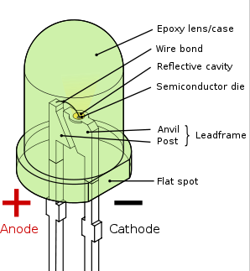

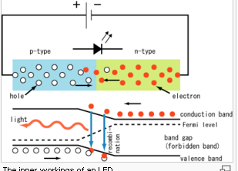

**Colors and materials :**

|  |  |  |  |  |
| --- | --- | --- | --- | --- |
|  | **Color** | **Wavelength (nm)** | **Voltage (V)** | **Semiconductor Material** |
|  | Infrared | *λ* > 760 | [Δ](http://en.wikipedia.org/wiki/Delta_(letter))*V* < 1.9 | Gallium arsenide (GaAs) Aluminum gallium arsenide (AlGaAs) |
|  | Red | 610 < *λ* < 760 | 1.63 < Δ*V* < 2.03 | Aluminum gallium arsenide (AlGaAs) Gallium arsenide phosphide (GaAsP) Aluminium gallium indium phosphide (AlGaInP) Gallium(III) phosphide (GaP) |
|  | Orange | 590 < *λ* < 610 | 2.03 < Δ*V* < 2.10 | Gallium arsenide phosphide (GaAsP) Aluminum gallium indium phosphide (AlGaInP) Gallium(III) phosphide (GaP) |
|  | Yellow | 570 < *λ* < 590 | 2.10 < Δ*V* < 2.18 | Gallium arsenide phosphide (GaAsP) Aluminium gallium indium phosphide (AlGaInP) Gallium(III) phosphide (GaP) |
|  | Green | 500 < *λ* < 570 | 1.9[[42]](http://en.wikipedia.org/wiki/Light-emitting_diode#cite_note-41) < Δ*V* < 4.0 | Indium gallium nitride (InGaN) / Gallium(III) nitride (GaN) Gallium(III) phosphide (GaP) Aluminium gallium indium phosphide (AlGaInP) Aluminium gallium phosphide (AlGaP) |
|  | Blue | 450 < *λ* < 500 | 2.48 < Δ*V* < 3.7 | Zinc selenide (ZnSe) Indium gallium nitride (InGaN) Silicon carbide (SiC) as substrate Silicon (Si) as substrate — (under development) |
|  | Violet | 400 < *λ* < 450 | 2.76 < Δ*V* < 4.0 | Indium gallium nitride (InGaN) |
|  | Purple | multiple types | 2.48 < Δ*V* < 3.7 | Dual blue/red LEDs, blue with red phosphor, or white with purple plastic |
|  | Ultraviolet | *λ* < 400 | 3.1 < Δ*V* < 4.4 | Diamond (235 nm) Boron nitride (215 nm)  Aluminium nitride (AlN) (210 nm)  Aluminium gallium nitride (AlGaN) Aluminium gallium indium nitride (AlGaInN) — (down to 210 nm) |
|  | White | Broad spectrum | Δ*V* = 3.5 | Blue/UV diode with yellow phosphor |